AGP: Change the seal model of Agimexpharm Pharmaceutical Joint Stock Company
On 28/02/2018, Agimexpharm Pharmaceutical Joint Stock Company announced the change in the seal model as follows:
Contents:
Change the seal model of the Company
Old seal model New seal model
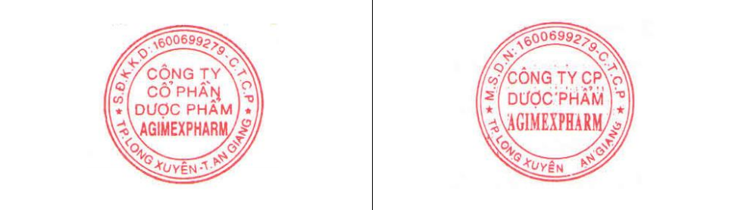

This information was disclosed on the website of the Company on 28/02/2018 as in the link: http://www.agimexpharm.com/quan-hr-co-dong/

